**Introduction to Key Word Sign – 02/03/2018 – DOT meeting**

**Resources to support signing:**

* **Key Word Sign Australia App**

This app allows you to:

* + Print out KWSA dictionary a-z or by category
  + Create & print individualised resources using line drawings of Auslan signs, Widgit symbols or photos from camera roll
  + Watch video clips of Interactive Vocabulary, numbers, alphabet or your own saved clips.
  + Designed for those who support children, adolescents & adults who use Key Word Sign
* **Getting Started with Key Word Sign** **book** (can be purchased through Key Word Sign Australia)

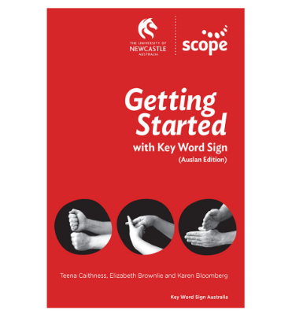

**Useful Websites:**

* www.scopevic.org.au/key-word-sign-australia/

Free download: Nursery Rhymes to Sing, See & Sign

* [www.auslan.org.au](http://www.auslan.org.au) (sign bank – has videos of Auslan signs – look for WA sign)
* [www.signplanet.net](http://www.signplanet.net)

Key Word Sign WA contact details:  
State Co-ordinator – Charlotte Wigham

For further information contact Key Word Sign WA   
Email:[keywordsignwa@gmail.com](mailto:keywordsignwa@gmail.com)

Don’t forget to like us on Facebook - Key Word Sign WA